|  |  |  |  |
| --- | --- | --- | --- |
| 1 | | 6,096 | |
| **NUMERO DE FRONTERAS** | | **ENERGIA AGREGADA** | |
|  | | | |
| 4,217,821 | 32 | | 195,033 |
| INGRESO 2021 | DÍAS CERTIFICADOS 2021 | | ENERGIA RESPALDADA 2021 |

**HISTORICO REINTEGRO DDV**

|  |  |
| --- | --- |
|  | **2021** |
| **ENE** | - |
| **FEB** | - |
| **MAR** | - |
| **ABR** | - |
| **MAY** | - |
| **JUN** | - |
| **JUL** | - |
| **AGO** | - |
| **SEP** | 2.12 |
| **OCT** | 2.1 |
| **NOV** | - |
| **DIC** | - |

**Los valores de la tabla están en millones de COP**

**REINTEGRO MECANISMO DDV OCTUBRE 2021**

|  |  |  |  |  |  |
| --- | --- | --- | --- | --- | --- |
| FECHA | TIPO DIA | CANTIDADES RESPALDO | PRECIO PONDERADO USD | TRM | PNETO |
| 2021-10-01 | Viernes | 6,095 | 5.98 | 3,784.44 | 123,590 |
| 2021-10-02 | Sábado | 6,095 | 5.98 | 3,784.44 | 123,590 |
| 2021-10-03 | Domingo - Festivo | 6,095 | 5.98 | 3,784.44 | 123,590 |
| 2021-10-04 | Lunes | 6,095 | 5.98 | 3,784.44 | 123,590 |
| 2021-10-05 | Martes | 6,095 | 5.98 | 3,784.44 | 123,590 |
| 2021-10-06 | Miércoles | 6,095 | 5.98 | 3,784.44 | 123,590 |
| 2021-10-07 | Jueves | 6,095 | 5.98 | 3,784.44 | 123,590 |
| 2021-10-08 | Viernes | 6,095 | 5.98 | 3,784.44 | 123,590 |
| 2021-10-09 | Sábado | 6,095 | 5.98 | 3,784.44 | 123,590 |
| 2021-10-10 | Domingo - Festivo | 6,095 | 5.98 | 3,784.44 | 123,590 |
| 2021-10-11 | Lunes | 6,095 | 5.98 | 3,784.44 | 123,590 |
| 2021-10-19 | Martes | 6,095 | 5.98 | 3,784.44 | 123,590 |
| 2021-10-20 | Miércoles | 6,095 | 5.98 | 3,784.44 | 123,590 |
| 2021-10-21 | Jueves | 6,095 | 5.98 | 3,784.44 | 123,590 |
| 2021-10-22 | Viernes | 6,095 | 5.98 | 3,784.44 | 123,590 |
| 2021-10-23 | Sábado | 6,095 | 5.98 | 3,784.44 | 123,590 |
| 2021-10-24 | Domingo - Festivo | 6,095 | 5.98 | 3,784.44 | 123,590 |

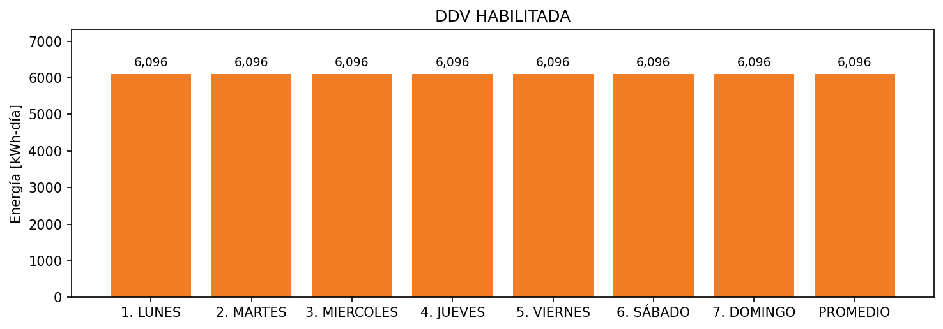

|  |  |  |  |  |  |  |  |  |  |
| --- | --- | --- | --- | --- | --- | --- | --- | --- | --- |
| **FRONTERA** | **COD SIC** | **FRT DDV** | **TIPO DDV** | **PROMEDIO** | **PRÓXIMA ACTUALIZACIÓN** | **MARGEN DE ERROR** | **ÚLTIMA PRUEBA DDV** | **DÍAS PARTICIPACIÓN** | **FECHA REFERENCIA PRÓXIMA PRUEBA DDV** |
| ESTELAR BOGOTA | Frt00920 | Frt36999 | GPE | 6,096 | 2023-04-15 | NO APLICA | 2021-09-03 | 32.0 | 2022-01-31 |